Lorem ipsum dolor sit amet, consectetur adipiscing elit, sed do eiusmod tempor incididunt ut labore et dolore magna

Alfredus Romulus¹, Bigottus Remus², Cleopatra VII Philopator^{1,2*}

¹Department of Molecular and Analytical Chemistry, University of Szeged,
6720 Szeged, Dóm square 7-8, Hungary
²Department of Analytical Chemistry, Eötvös Lóránd University,
1117 Budapest, Pázmány P. promenade 1C, Hungary
e-mail: philopator@chem.u-szeged.hu

All lines in the document are spaced single (1.0), with no extra gaps after paragraphs. The font style is Cambria everywhere. Page size is A/4 with 2.2 cm margins on all sides. The title is in the top line, printed in bold, font size 14 pt, centered, all letters capitals. The title is followed by an empty line and then come the authors’ full names (middle names abbreviated), in the English order, printed in bold, font size 12 pt, centered. The presenting author’s name is underlined and the corresponding author’s name is marked with an asterisk in superscript. The author line is followed by an empty line and then come the authors’ affiliations, individually numbered in superscipt. Each affiliation starts on a new line and is centered, font size 10 pt. The next line is the e-mail address of the corresponding author, centered, 12 pt [1, 2].
Main body of text is preceeded by an empty line, and is all justified, printed in font size 12 pt. The first paragraph starts with no indentation, while all others have indentation in the first line. If there is illustration inserted, it has to be centered, with a max. 5 cm height. The illustration is preceeded with an empty line, but is immediately followed by the caption (optional), which is centered and is printed with font size 10 pt. The caption, or the illustration, is followed by an empty line [3].

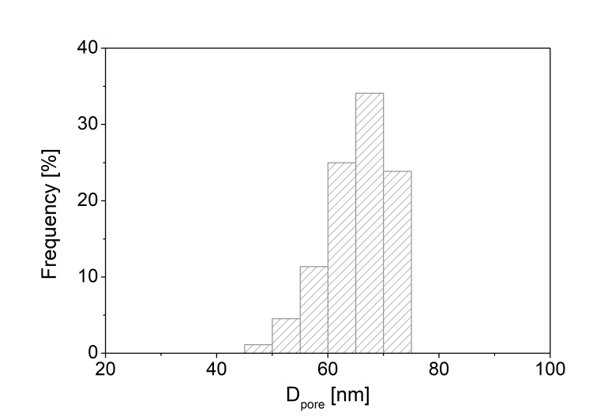
Lorem ipsum dolor sit amet, consectetur adipiscing elit

If there is a list of references, an empty line separates it from the body of text. In the text, all citations are referenced by a number placed in square brackets. The list of references is left-aligned, printed in font size 12 pt. Other formatting details of the references can be seen below [4].

[1] C. Cicero, B. Romulus, A. Remus, J. Roman Sci., 217 (2003) 137.
[2] C. Cicero: Lorem ipsum, Nero Publishing Company, 1988.
[3] C. Cicero, PhD dissertation, University of Szeged, 2009.
[4] C. Cicero, poster #123, 2nd Mediterr. Conf. Aggressors, Rome, 1994.

